Exams Held Outside of Class Times

Usage guidelines
The Schedule Change Request Form (SCRF) is not to be used to request approval for exams held outside of normal class meetings. The form is only to add notes about previously approved exams to the Schedule of Classes prior to the start of registration as required by University Senate By-Laws. The Office of the Registrar is not involved in the exam approval process itself. For more information, contact your dean's office. Departments may contact the Registrar's Office at registrarscheduling@uconn.edu once the note has been added to reserve rooms for the exams.

Using the SCRF to add exam notes
To access the form, you may launch the form directly or use the links on scheduling.uconn.edu.
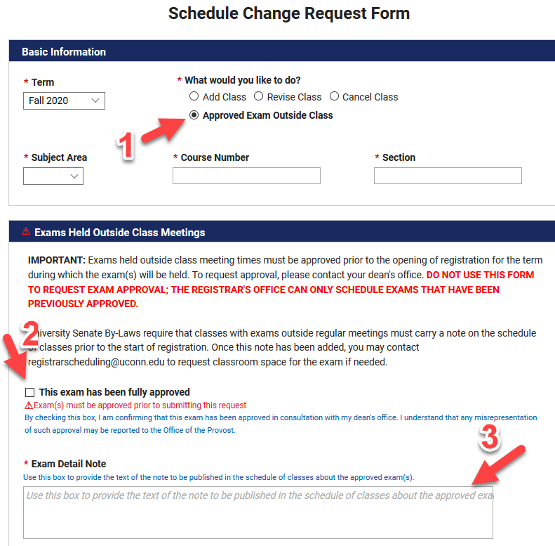
- Select "Approved Exam Outside Class" to display the necessary fields.
- Check to confirm that the exam has been approved. NOTE: Records for exam requests will be preserved and may be provided to the Office of the Provost if requested.
- Provide the text of the exam details exactly as you would like them to appear in the schedule of classes.

Fall 2020 registration begins March 23, 2020.
Text of new By-Law: "During the semester or term, assessments shall be held only during regularly scheduled class periods. If instructors, due to exceptional circumstances, believe they need to hold assessments outside of regularly scheduled class periods, they must seek approval from the Vice-Provost for Academic Affairs prior to the start of registration. Sections of courses for which such exception has been granted shall carry a footnote to that effect in the published Schedule of Classes and be clearly states the date and time of the assessment on the syllabus” See policy.uconn.edu for more information.

