Creating and Updating Classes
The same form is used to create new classes and to update existing classes, but there are some key differences depending on which action you're taking. We'll start with editing an existing class.

Editing Existing Classes
It is possible to edit both classes that appear on the proof and classes newly added either by you or another user in your department. The example below uses a class that was imported as part of the proof.
When you first open an existing class, you will be asked to click a button to continue. This allows the system to ensure that only users authorized to access that subject area may view the class:
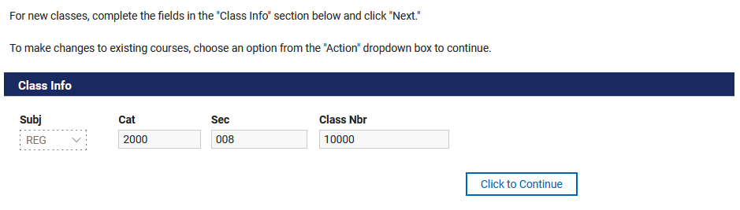
If you are not authorized, you will get an error message:
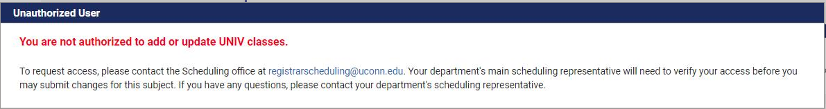
If you do have access, you will see the class details broken down into five sections:
- Basic Information
- Class Meetings
- Instructors
- Reserve Caps
- Combined Sections
To continue, you must choose "Revise Class" or "Delete/Cancel Class" from the Action dropdown or check the "No Changes Necessary checkbox:

Deleting/Canceling Classes
If you select "Delete/Cancel," you'll get a quick confirmation message; once you click OK, the system will allow you to submit the update:
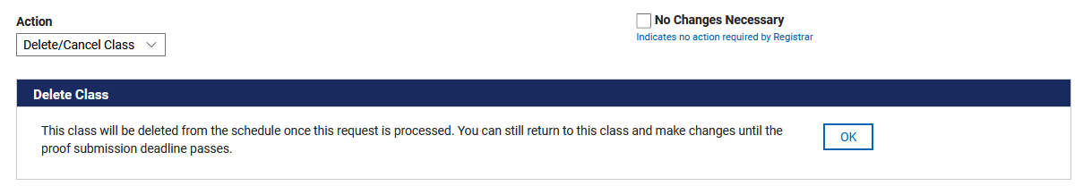

No Changes Necessary
You may also check the "No Changes Necessary" box if no changes need to be made. This is totally optional; the only purpose of this checkbox is to allow departments to flag requests that require no changes but have been reviewed to distinguish them from those that have not been reviewed. The Registrar's Office will interpret these classes and those left untouched in the Proof stage the same way – no changes will be made.
If you choose this option, you will be given a brief confirmation message. Once you click OK, the system will allow you to submit the update:
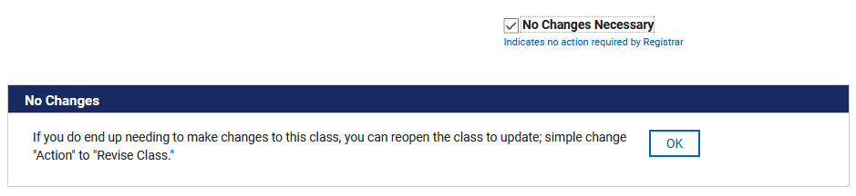

Revising Classes
When the form for an existing class first loads, all of the fields will be grayed out and read-only. This is to allow users to review the class details before deciding which, if any, changes need to be made. Select "Revise Class" from the Action drop down and click the "Click to Continue: Revise Class" button to edit details:
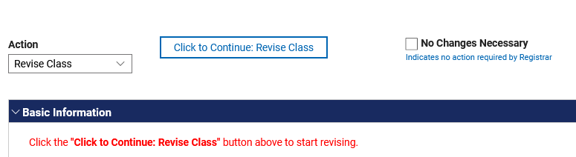

Basic Information section
When you click the button, you will notice that new, empty fields appear below the grayed out fields (outlined in green in the image below). This will allow you to enter the new details as needed while comparing to what is currently in the proof. Only update the fields that are changing; unchanging fields should be left blank.
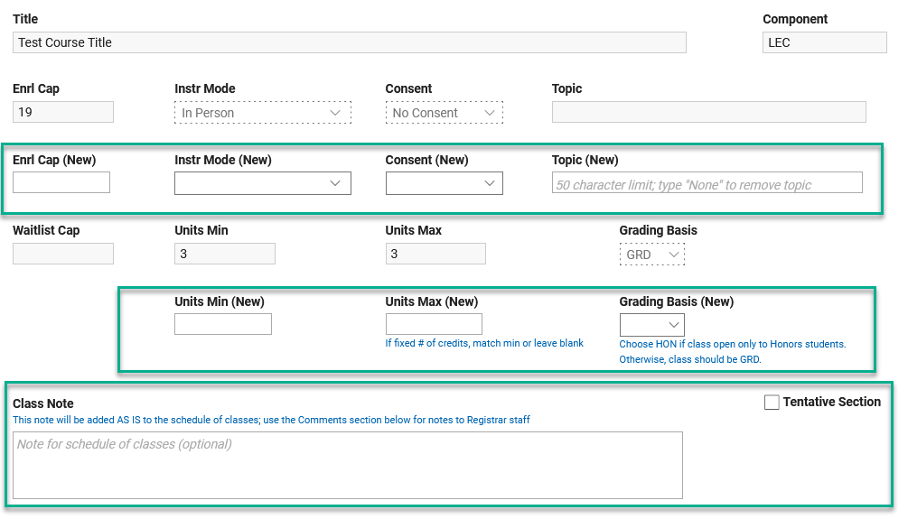

About Units (Credits) and Grading Basis
The fields to adjust units only appear if a class was approved as a variable credits class in the course catalog. The only purpose of the Grading Basis field is to switch between graded and honors. Classes may only be placed on the satisfactory/unsatisfactory grading basis if they are approved as such in the course catalog.

Class Meetings
The Class Meetings section displays the days and times the class is currently set to meet in the proof. This field will be blank for "by arrangement" and asynchronous online classes with no set meeting times. You only need to complete this section if a change is being made. To change class meetings, click "Edit Meetings" (if this is grayed out, it means you have not selected "Revise Class" as indicated above). This will load the meeting data from the proof and allow you to make changes:
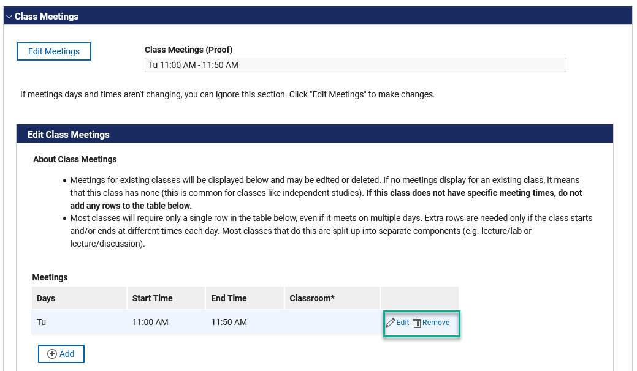
Click the Edit icon to revise the existing meetings. Alternatively, you can click Remove and Add a new row. Only in very rare cases are more than one row of meeting data necessary. For example, if a class meets on multiple days but at different times, you may need an additional row. However, most classes like this are split up into separate components (e.g. lecture/lab or lecture/discussion).
When you click Edit, a window will open that will allow you to specify class days and times:
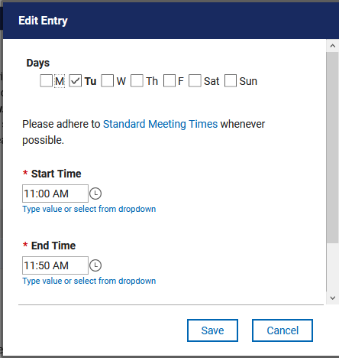
Please note that changing times can be tricky at first. By default, the time fields provide a dropdown menu with times in 15-minute increments. If none of those times work, you can simply type in the time you need. We understand that this interface is not particularly intuitive but unfortunately it is what comes with the product and we can't change it.
Note: The preview field that indicates what's on the proof - "Class Meetings (Proof)" – will not update as you make changes to class meetings; it is merely meant to serve as a comparison to the original information. This is also true for the preview fields for instructors, reserve caps, and combined sections.

About Classrooms
You will notice that this window also allows you to specify a classroom. This should only be used to specify a department-controlled space. Please do not use this to request a particular centrally controlled classroom. Such requests cannot be honored.

Instructors
As with Class Meetings, the form will only display a summary of instructors assigned to the class, if any. Only complete this section to make changes to instructors.
To get started, click "Edit Instructors" (if this is grayed out, it means you have not selected "Revise Class" as indicated above):
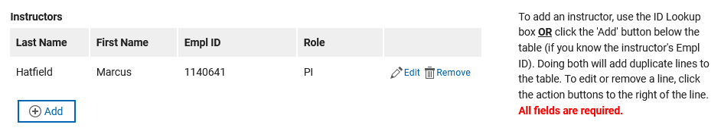
Like the Class Meetings section, all assigned Instructors will be loaded into a table. Add, edit, and remove rows as needed. Please note that all four fields are required. For your convenience, the form also features an ID lookup tool if you do not know an instructor's ID. Once you've found the ID you're looking for, you will be asked to provide the instructor's role and then you may click the "Click to Add" button in the Results section that appears, which will automatically add the instructor to the table:
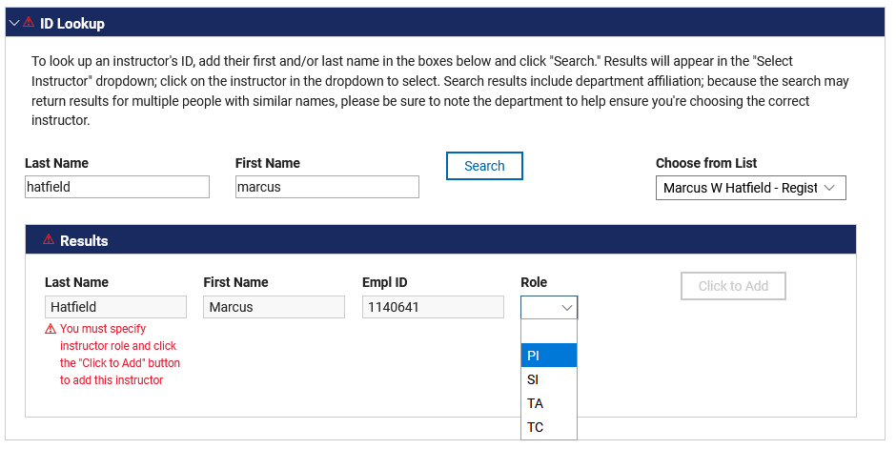

Reserve Caps
If a class has a reserve cap, it will be displayed here. To make any changes, please choose an option from the drop box (the Reserve Cap Details field won't display unless you choose "Other Changes"):
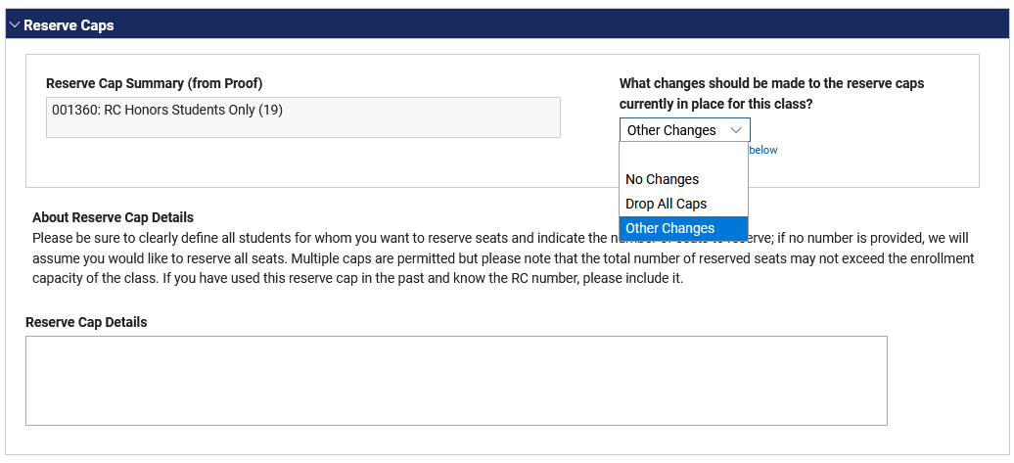
If the class has a reserve cap but no changes are required, you may select "No Changes" from the dropdown box or ignore this section altogether.

Combined Sections
This section allows you to combine this class with another or to edit any existing combinations – including an option to uncombine all classes. If the class is combined with one from another department or school, please be sure to communicate with that department before making any changes:
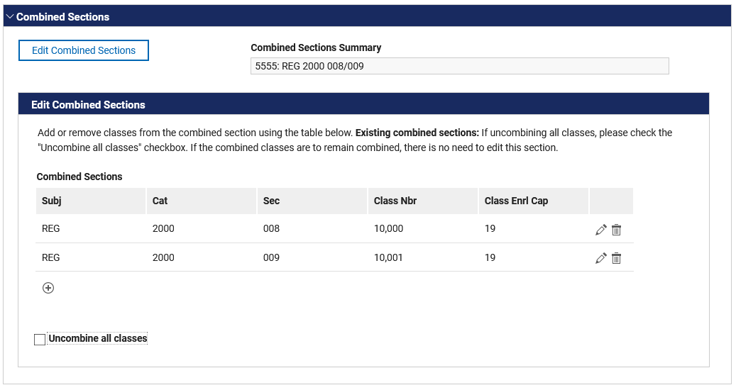

Comments
The last section on the form is a comments section. Please use this for special instructions (the Class Notes field above is only for notes that will appear on the schedule) to the Registrar if these cannot be communicated in the fields provided. If you anticipate having more than one person in your department review requests, you can also use this to communicate with those users:
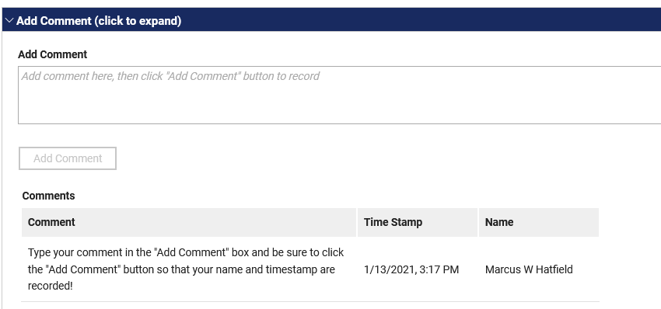

Adding New Classes
As mentioned above, new classes and existing classes use the same form, so most of the functions will be exactly the same. That being the case, we'll just touch upon the differences between the two actions.
When you create a new class, you'll first need to specify the subject area, catalog number, and section number. Then click "Click to Continue."
If you enter a class that already exists, you will get an error message. To open that class, click on its row in the table and click the "Click to View…" link. If you simply need to specify a new section, click the "Change Subj/Cat Nbr/Section" button to start over.
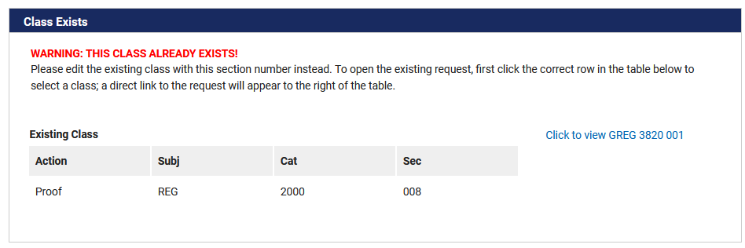

Basic Information
This section is identical to how it looks when revising classes except that there are no grayed out fields with pre-loaded information. There are also a couple additional questions that apply only to lab, discussion, or clinical sections connected to a lecture class:
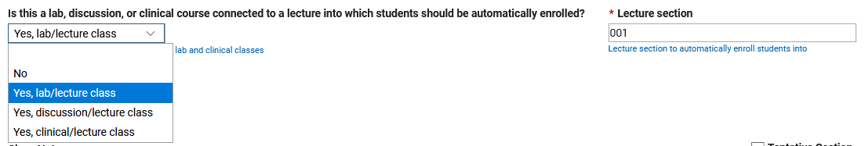
"No" is selected by default. If this does apply, select the correct option from the dropdown and let us know which lecture section with which we should associate the class.

Class Meetings
The Class Meetings section is the same as above except that it also allows you to specify that a class has no pre-determined meeting times (for by arrangement and asynchronous online classes). You must either check this box or add class meeting information in the same manner demonstrated above:
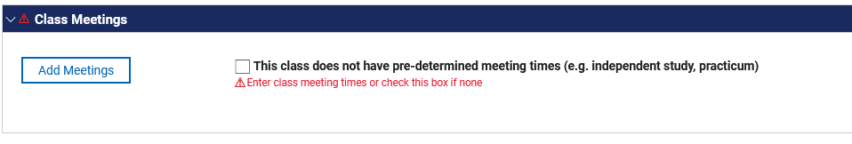

Instructors, Reserve Caps, and Combined Sections
These sections are all identical as the examples above except that no information is pre-loaded from the proof.

There is no approval workflow integrated into this system; for maximum flexibility, it is designed to allow multiple users from the same department to view and edit classes upon departmental request. However, it is up to each department to ensure that the users it has authorized to use the system do not make unapproved changes.

