Using the SUPER User Dashboard

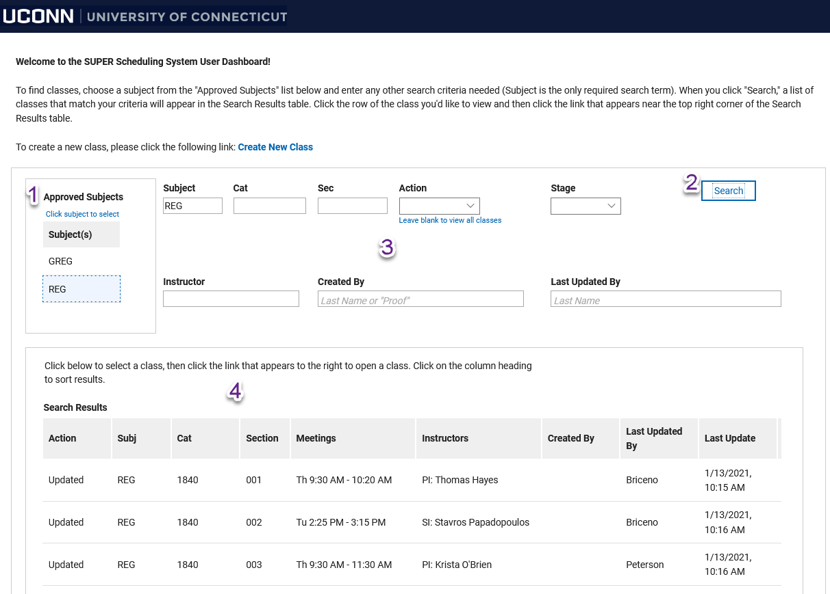
Searching for Classes
The User Dashboard is the place to find existing classes or to create new classes. All existing classes have been preloaded into the system.
When you log in, any subject area(s) you are authorized to access will appear in the "Approved Subjects" table (1). To search, click the row of the subject you'd like to view and then click the Search button (2). You can refine your search by filling in any of the other search fields (3) or leave them blank to view all classes. For the "Instructor," "Created By," and "Last Updated By" fields, you can enter a portion of an instructor or user's name to see results.
The "Action" field indicates whether a class is new or whether any actions have been taken on an existing course. There are five Actions:
- Proof: This class has not been revised and appears exactly as it does in the system.
- New: Indicates that this class was not on the proof but rather added by a user (more about creating new classes later).
- Updated: This class was in the proof and has been revised in some way by a user.
- Deleted: This class was marked by a user to be deleted by the Registrar's office
- No Changes: This class was reviewed by a user and it was determined that no changes are necessary. This is an optional field to help users distinguish between classes that require no changes and those that simply have not been reviewed yet. It is not required; you may also simply leave the class as is in the Proof stage.
The "Stage" field largely duplicates what is in the Action field. Users are free to use it if they want but it is primarily for use by the Office of the Registrar when processing changes. However, it may be useful to distinguish between classes that have had ANY action taken and those that remain exactly as they were in the proof stage.

Search Results
Results will appear in a table (4) below the search fields. Results are sorted by catalog number, but you may re-sort by any field by clicking on the gray column heading. (Our example uses a fake subject area but borrows details from real classes in case you see your name here and are wondering why ).
The table has 10 columns total but the last one (Stage) is cut off in our sample screenshot. You can resize any column by dragging the white line between each column heading or use the horizontal scroll bar at the bottom of the table to see more. The following is a bit more detail about some of the columns:
- Meetings: A brief summary of meeting days and times. This column will be blank for new classes added by users.
- Instructors: A brief summary of assigned instructors. Not all instructors will appear here, and this will be blank for new classes.
- Created By: Indicates the creator of new classes.
- Last Updated By: The last user to take any kind of action on the class.
Note: You can scroll through the list to see all classes but you may need to use the horizontal scroll bar at the bottom of the results table to see the vertical scroll bar on the right. If you resize the columns so that they are narrow enough, you will be able to see the scroll bar:
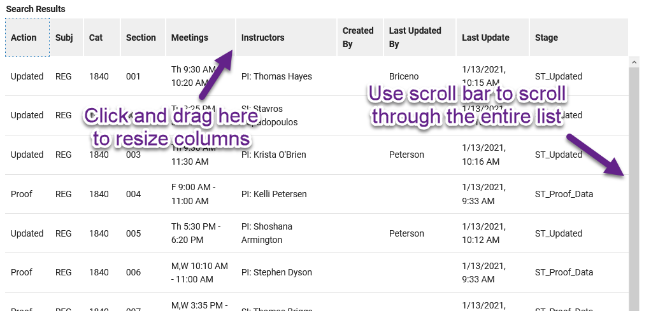

Opening Classes
To open a class in the search results, click the row of the class you want and then click the hyperlink that appears in the top right corner of the Search Results section:
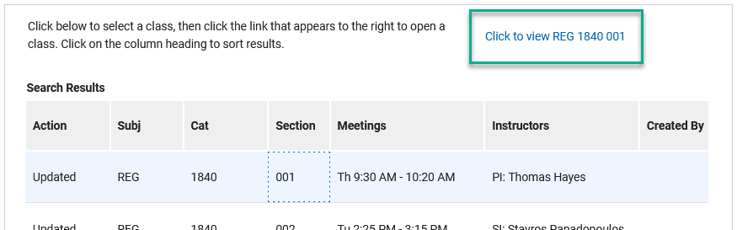

Create a New Class
To create a new class, click the "Create New Class" link in the text above the search fields to launch a new class request form:
